# CS 255 System Design Document Template

This template lays out all the different sections that you need to complete for Project Two. Each section has guidance to prompt your thinking. You will need to continually reference the interview transcript as you work to make sure that you are addressing your client’s needs. There is no required length for the final document. Instead the goal is to complete each section based on what your client’s needs are. Remove this note when you are finished, and replace all bracketed text with the relevant information.

## UML Diagrams

### UML Use Case Diagram

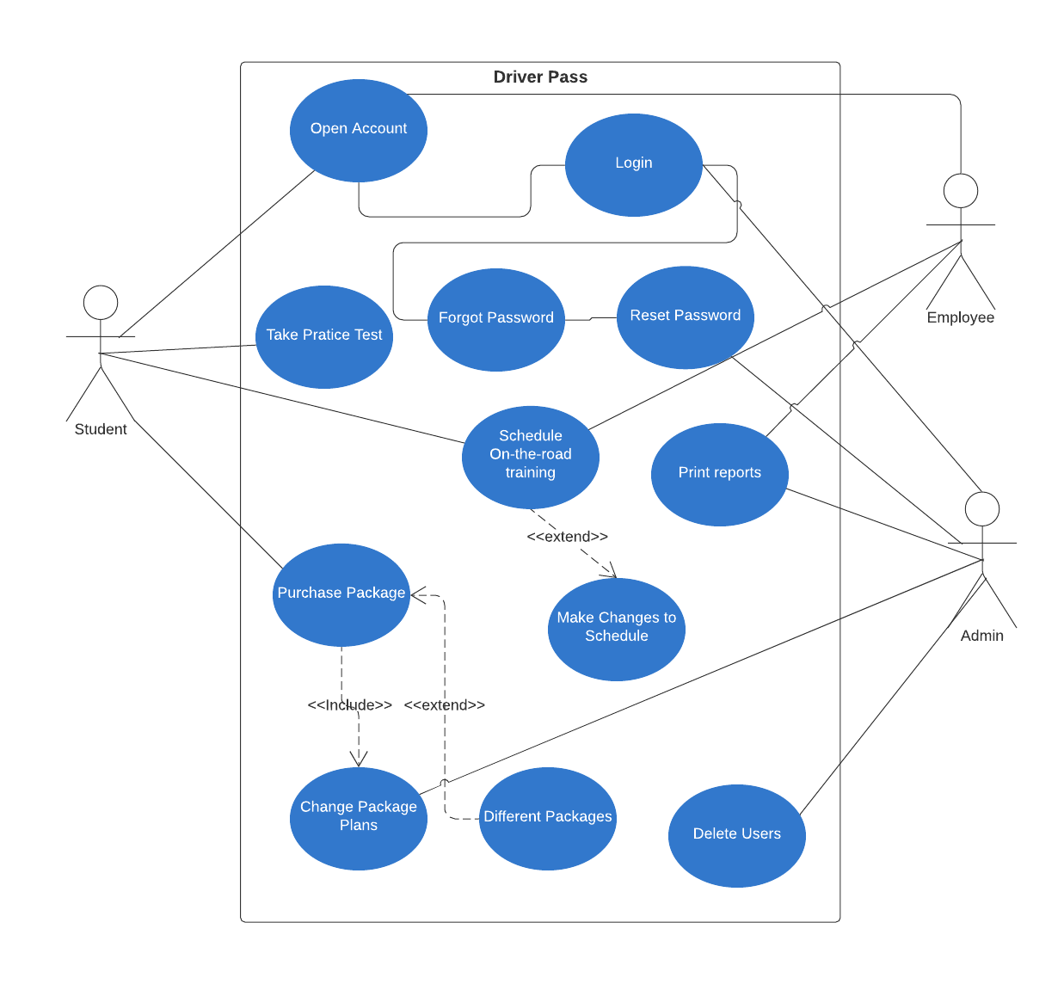

### UML Activity Diagrams

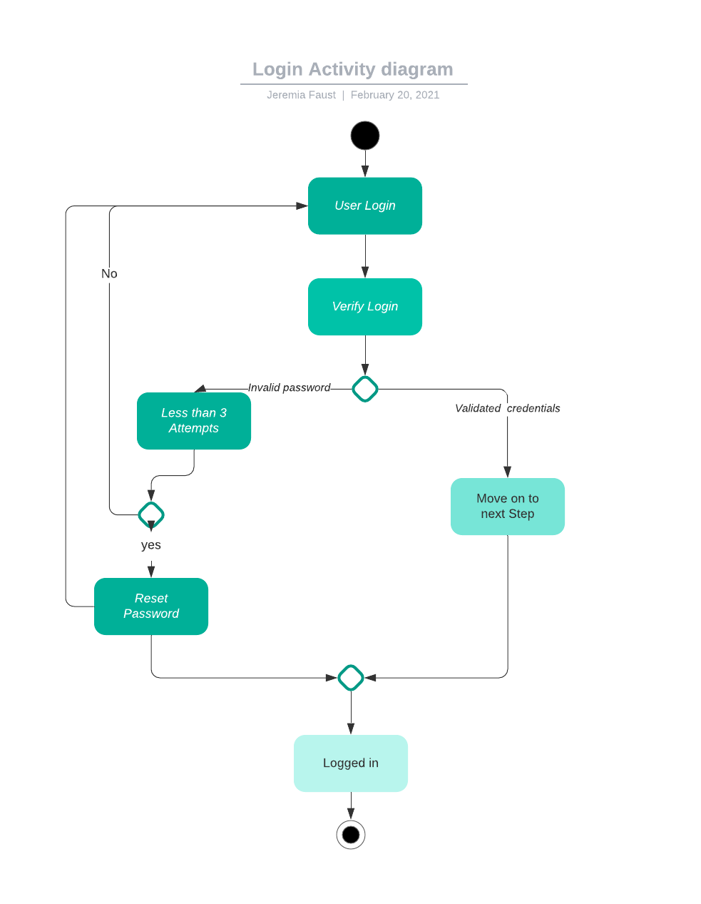

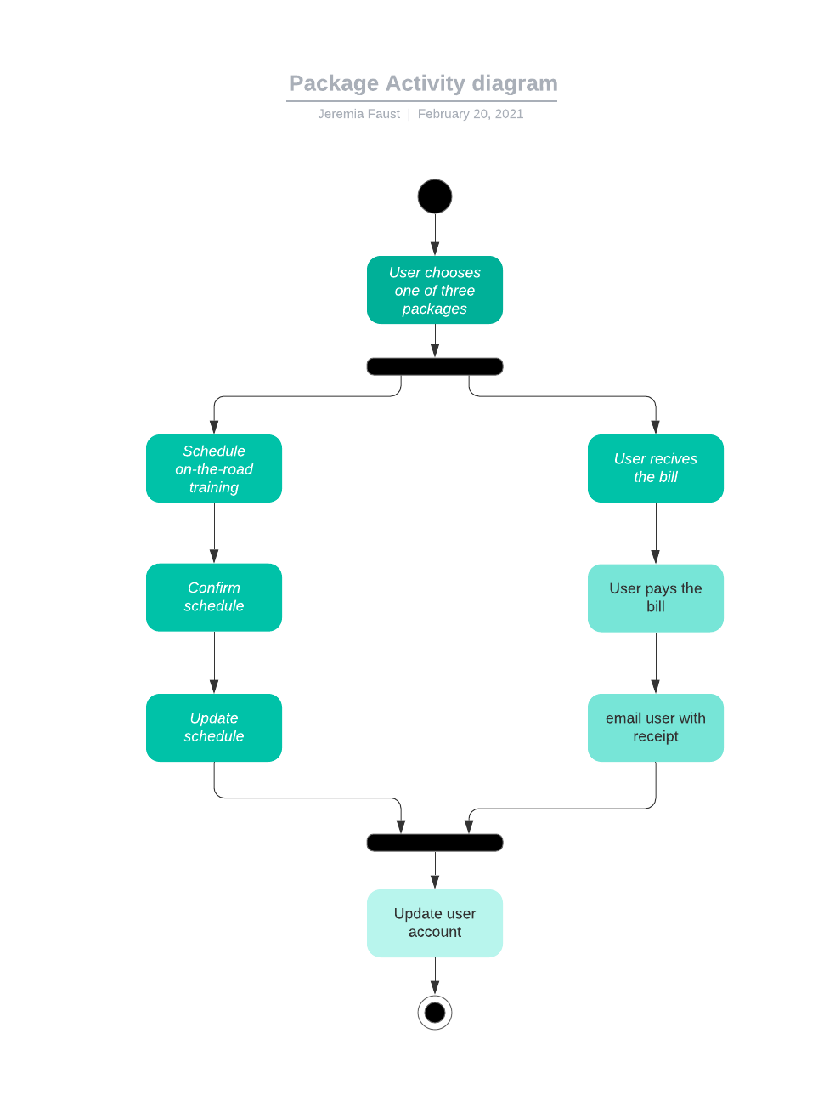

### UML Sequence Diagram

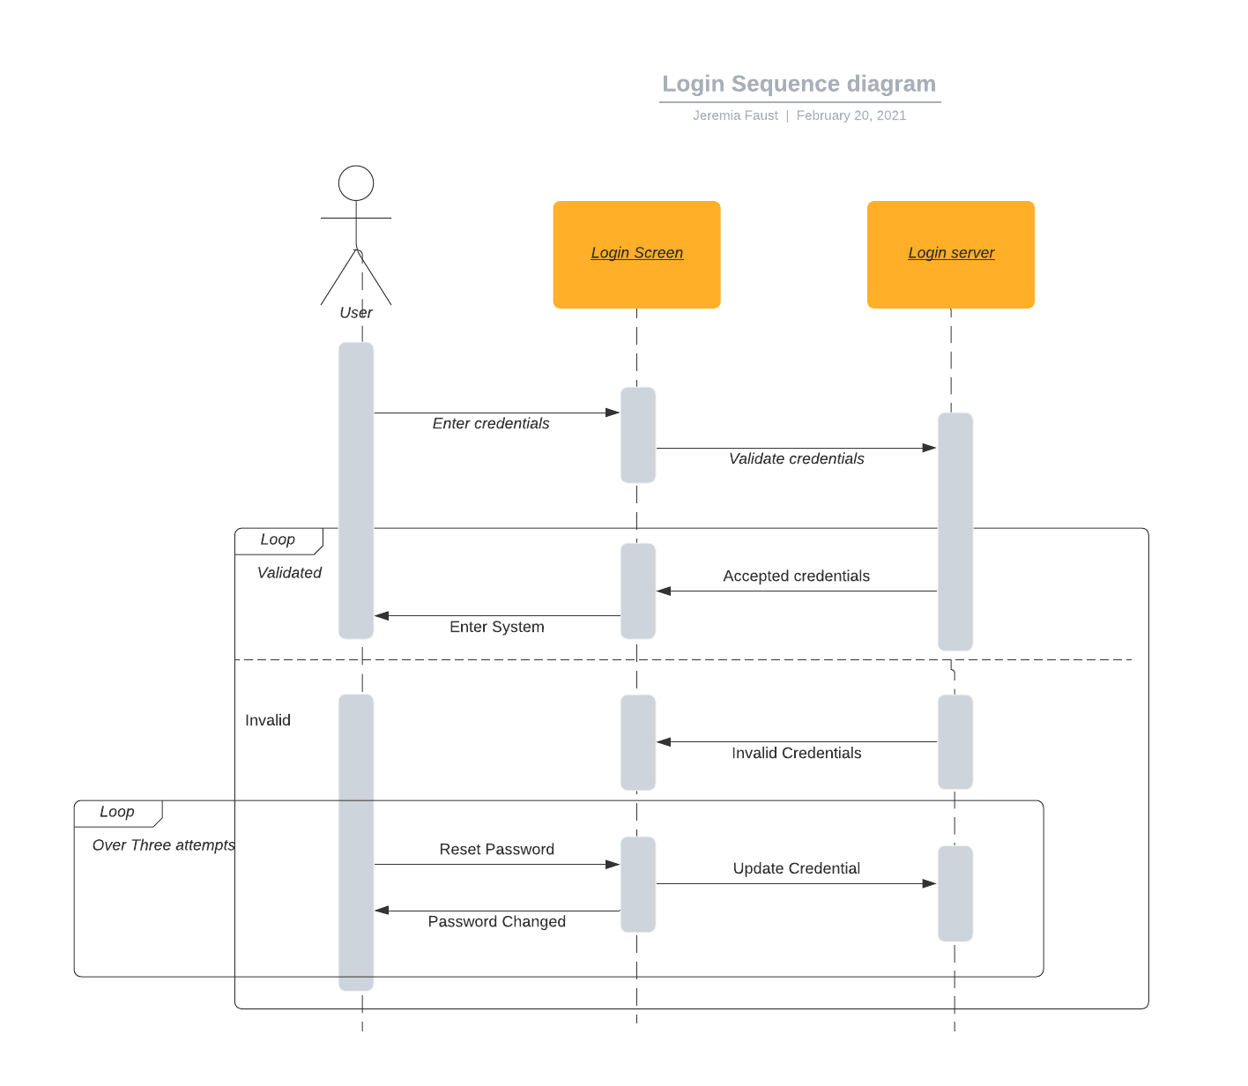

### UML Class Diagram

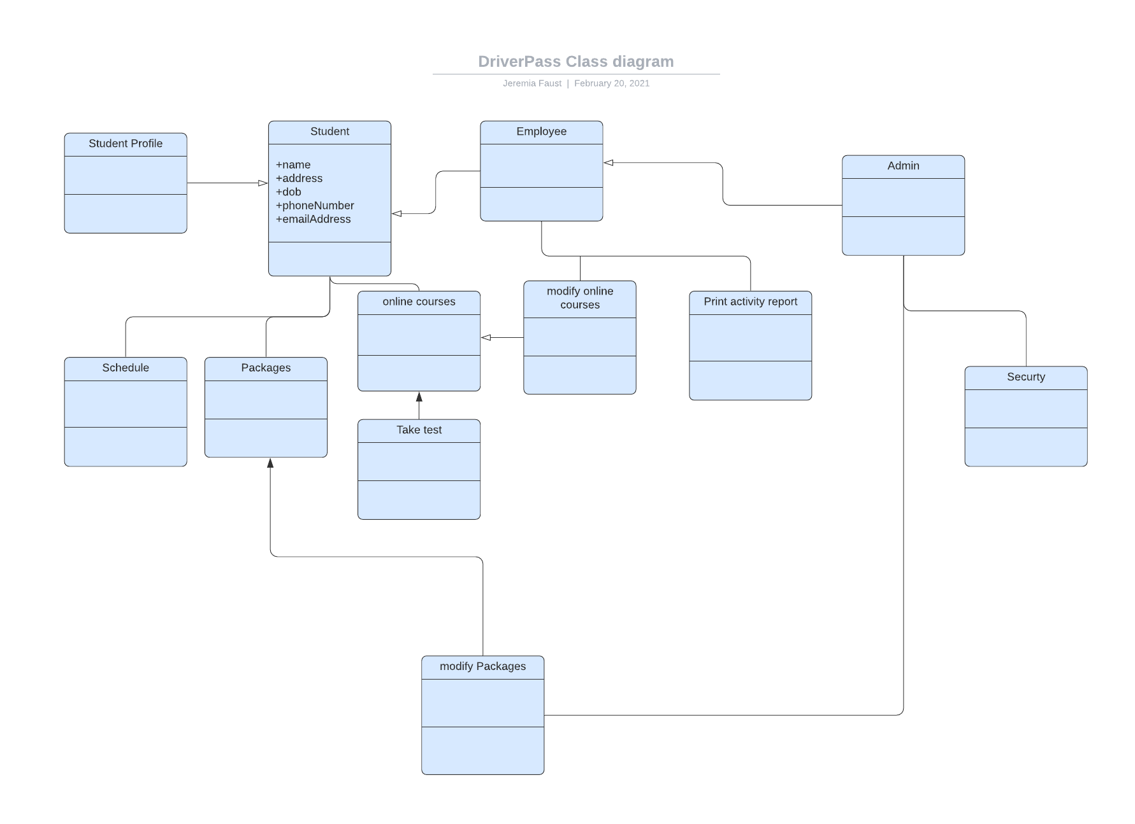

## Technical Requirements

*[Based on the diagrams you have created, describe the technical requirements of your system. These requirements should address the required hardware, software, tools, and infrastructure necessary for your system design.]*

This system will run primarily using cloud technology. I recommend using Microsoft azure cloud. I chose this service because Windows is a system that everyone understands and is very easy to use. Although this system can run on any device it is recommend that you have high speed internet at the office for quick and efficient service to you customers during your hours of operation. You can have any basic computer setup in office to run and maintain this system since most of the hard work is done on the cloud. Instead of creating a schedule software it may be cheaper and faster to integrate existing software.

Cloud computing Services: Microsoft Azure. (n.d.). Retrieved February 20, 2021, from https://azure.microsoft.com/en-us/